

“Bridging the gap between autism and eating disorders research”

Pictorial Participant Information Sheet
Neuroanatomical Differences Associated with Anorexia Nervosa and Masking Behaviour in Autistic Individuals

You are being asked to take part in a research project investigating the relationship between brain structure, eating disorder (ED) symptoms and masking behaviour in Autistic individuals. Masking is a strategy used by Autistic people, whether conscious or unconscious, to ‘blend in’ with neurotypical peers.

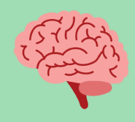


This research is associated with the Eating Disorders and Autism Collaborative (EDAC), a UK-wide collaborative network of autism and eating disorder researchers. The entire EDAC team can be seen below, but this study will be headed by Dr Michelle Sader (top-right) and Dr Gordon Waiter (bottom-middle). This research has also been funded by EDAC.
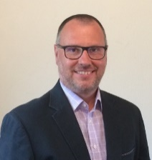
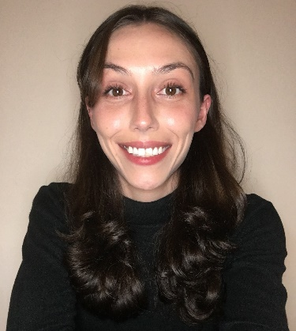

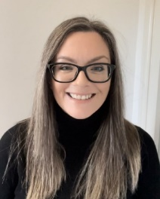


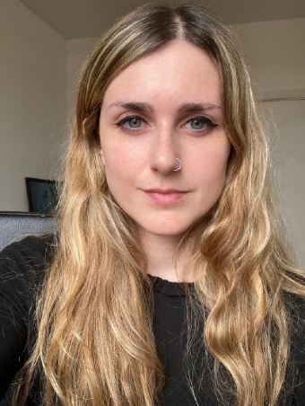
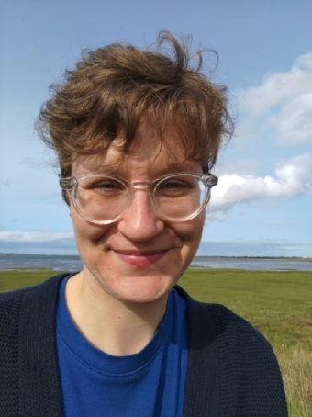
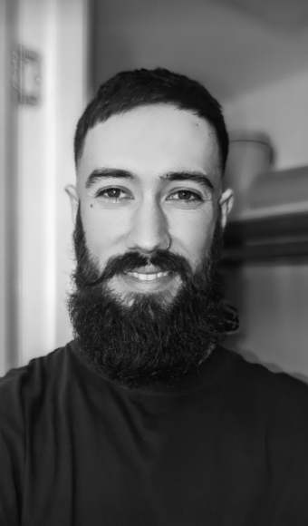

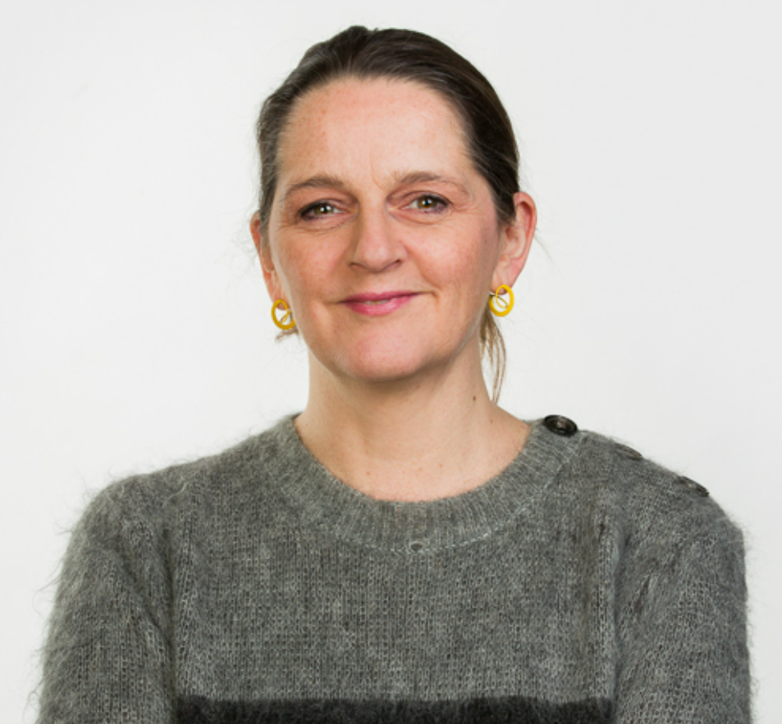
Dr Michelle Sader
Dr Gordon Waiter
Dr Emy Nimbley
Dr Karri Gillespie-Smith
Dr Fiona Duffy
Ellen Maloney
Dr Jess Kerr-Gaffney
Kyle Buchan
Prof Kate Tchanturia
Dr Helen Sharpe
Prof Sarah Kettley

Before deciding to take part in this project, it is important that you are provided with information concerning the purpose of this research, and what participating will involve. Please do take time to read the following information carefully, and do not hesitate to ask any questions. Contact information will be provided at the end of this sheet for any questions. For your own records, please do print this sheet, or take a screenshot of the following information.

What is the purpose of this study?

This research aims to explore how EDs such as anorexia nervosa affect Autistic people and to examine any links between masking and ED symptoms. Participants will complete online questionnaires about their Autistic traits, ED symptoms, and masking behaviour.


To get a clearer picture of how the brain is involved in masking for Autistic people with and without a restrictive ED, participants will also have a magnetic resonance imaging (MRI) scan, which is a safe way to take detailed images of the brain.
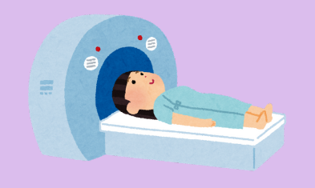

Are you eligible to participate in this study?
You have been invited to take part in this study as you fulfil criteria for this research. This means you are:
- Between 18-45 years old
- You are Autistic (clinically diagnosed) with an Autism Quotient (AQ-10) score of 6 or higher*
- You belong to one of the following groups: 1) you have a current experience of anorexia nervosa; 2) you have no previous history of an eating disorder
- You have no known history of brain injury of trauma (e.g., stroke, chronic traumatic encephalopathy from multiple concussions, etc.)
- You have no contraindications to MRI, such as implantable cardiac devices, and are willing to have an MRI scan in Aberdeen
- You can read, understand and respond to questionnaires in English

As participants will need to consent to the study and complete questionnaires by themselves, individuals with intellectual disability will be excluded from this study.

*Scores on the AQ-10 are in no way intended to make statements on your identity as an Autistic person, rather these scores are used to confirm participant eligibility for this pilot research and ensure good scientific practice.

Do you have to take part in this study?

You do not have to participate in this research. Taking part in this study is completely up to you!
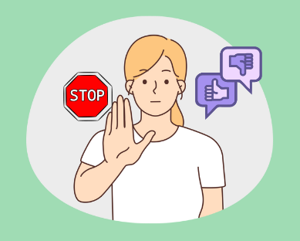

If you do decide to participate, you will be asked to complete an informed consent sheet before taking part in any steps of the research process, in order to demonstrate that you fully understand the purpose of this study, and that you indeed want to take part. Within this consent form, you will also be asked to optionally consent to us retaining your contact details for the purposes of sending you a lay summary of the study results and copy of your brain scan once the study is completed. You will be able to complete this informed consent sheet either online or in-person, depending on your preference.

What happens if you decide to take part in this study?

If you do decide to participate in this research, you will fill in a series of ten questionnaires that will evaluate demographics (e.g., age, ethnicity, etc.), Autistic characteristics, ED symptoms, how likely you are to focus on a selective or small number of interests and masking behaviour We will also ask about your levels of anxiety or depression, and any work or social adjustments you may make.
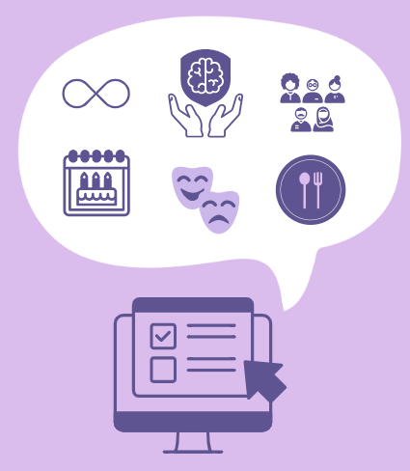

After completing the questionnaires, we will ask you to have a brain scan that will last approximately 45 minutes at Aberdeen Royal Infirmary (ARI). You may choose to complete these questionnaires either online, or during your in-person visit to the ARI alongside your MRI scan. For individuals not local to Aberdeen who may have to travel for this brain scan, the research team is able to offer up to £25 to compensate individuals for travel to ARI. You will be compensated for your participation in this study in the form of a £30 Amazon or Love2Shop voucher, depending on your preference. After participation, you will also be asked to complete an optional feedback survey on your experience participating in the study. During your MRI scan, you will be asked to lie flat on a bed, which is moved into the middle of the scanner. We will ensure you are comfortable and assist you on to the scanner bed if mobility is challenging prior to initiating the scan. An image of the MRI scanner you will be in can be seen below:
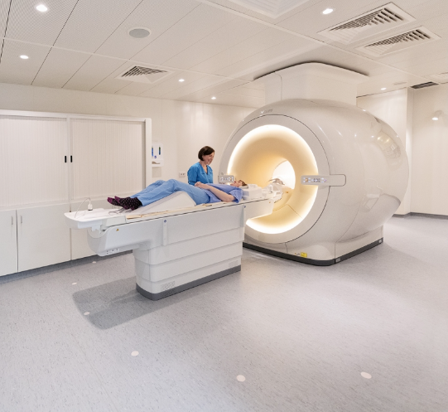

The MRI can be quite noisy but we will provide you with ear plugs and ear defenders to protect your hearing. We can also dim the lights of the scanner room to make the environment more accessible and comfortable for you. If you have a fidget toy or comfort object that does not contain any metal, you may be able to bring it with you to hold during your scan. If it is unclear what material your fidget toy or comfort object is made of, radiographers may need to confirm that the object does not contain any metal before your scan. You will be able to speak to the radiographer the entire time.
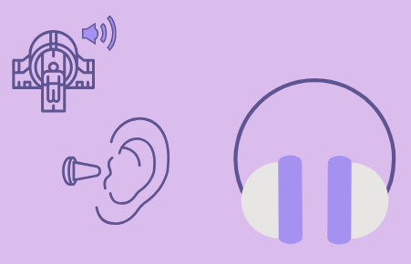
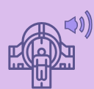

If you need to stop for any reason, we will bring you out of the scanner as needed. You will be given a call button that you can squeeze at any time if you would like to stop the scan and be taken out of the MRI.
For some individuals, the enclosed tunnel/space associated with the MRI can bring about feelings of anxiety. We will immediately remove you from the MRI if you feel uncomfortable in any way.
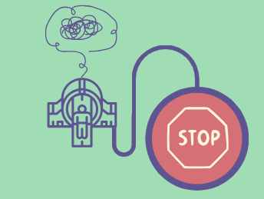

More information associated with receiving an MRI can be found on the NHS website here. In total, we expect the total time of participation to consist of 3 hours, however we only anticipate the MRI scan to last 45 minutes. With your permission we will inform your GP that you are taking part in this study.

What are the benefits of participating?

There are no benefits to you individually but by providing your answers to the questionnaires, and by having a brain scan, you will be helping EDAC understand the role an ED plays in Autistic people, and whether masking behaviour is associated with ED symptoms. Understanding these differences in Autistic people with an ED relative to Autistic people without an ED will help health services plan how to improve ED interventions for the Autistic community.

Are there any risks associated with participating?

There are minor risks to an individual’s level of anxiety, as the MRI can bring about discomfort due to the noise associated with a scan, or the enclosed space an individual will need to lie within during the scan. The MRI also uses magnets to visualise the human body, as such it is important to inform the research team if you have any metal implants, pacemakers or other electronic devices in your body. This does not include passive metal implants, such as aneurysm clips or catheters, that do not need an external power source to work. There is also a very rare occurrence that we may notice something in your scan that may require further attention or support from health services. Prior to your scan, you will complete an MRI safety sheet to ensure you are safely able to undergo an MRI scan. If there is any uncertainty with which a participant may be pregnant, they will be withdrawn from the study.
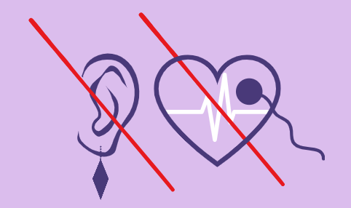

What will we do if we notice something in your scan?

The MRI scans taken for this research project are not the same as those that would be needed for clinical diagnostic purposes. However, in the event the radiologist collecting the scan notices something of medical relevance, a relevant health professional will discuss these findings with you and will pass this information onto a relevant health professional if required. If you agreed, we would also inform your GP.

What if you no longer want to participate?

You have the right to withdraw from this study at any point of the research process by either not responding the online questionnaires that have been sent to you, or by emailing the study principle investigator (michelle.sader3@abdn.ac.uk). Data collected up to the point of your withdrawal will be retained and used in the study.

Data protection and confidentiality

Information and data generated from this study will be collected and processed in line with the UK Data Protection Laws adhering to the University of Aberdeen’s Data Protection policies. All personal data will be kept strictly confidential, with pseudonyms or numerical codes used to protect your identity. Personal information (e.g., names, locations, etc.) will be removed from data analysis, with other personal data recorded for the purposes of research (e.g., age, gender, location, ethnicity, etc.) stored on University of Aberdeen servers, which are encrypted and password protected. MRI scans will also be stored on University of Aberdeen servers, and can be made available to individual participants upon request. De-identified data and scans will be stored for a minimum of 10 years on an online data repository, and may be used by other researchers for ethically approved, autism-affirming research.
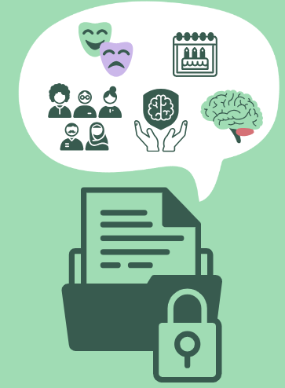

The University of Aberdeen will act as the data controller for this study, meaning we are responsible for taking care of the information you have provided in order for you to participate in this study, and using it properly with regards to protection of your privacy. Contact information (e.g., email addresses), will be retained until the end of the study, and upon participant consent to retain personal data for future ethically approved studies, will be retained for 5 years.
More information regarding the protection of your data may be found here.

How will we use information about you?

In this research study we will use information from you. We will only use information that we need for the research study. We will let very few people know your name or contact details, and only if they really need it for this study.
Everyone involved in this study will keep your data safe and secure. We will also follow all University of Aberdeen privacy rules. At the end of the study and upon your consent for us to safely retain your data, we will save your data for 10 years and your contact details for 5 years for future ethically approved research.
We will make sure no one can work out who you are from the reports we write.
The main participant information sheet will tell you more about how we will use your information.

What will happen with the results of this study?

The results of the study will be used to inform on brain structure and function specific to Autistic individuals with versus without an ED. This will involve dissemination of findings from this study on the EDAC website (edacresearch.co.uk), as well as via a publication published on a peer-reviewed journal. All findings from this research will be made available using open-access means, and can be accessed by anyone. It will not be possible to identify you from any publications.

Who has reviewed this study?

This study has been reviewed and received ethical approval from the Camberwell St Giles REC.

Who am I able to contact?

If you wish to take part in this study or have any questions, please contact Michelle Sader via the following information:

Dr Michelle Sader Michelle.sader3@abdn.ac.uk +44 (0) 1224 38365 School of Medicine, Medical Sciences and Nutrition The University of Aberdeen Lilian Sutton Building Foresterhill Campus Foresterhill AB25 2ZN
Dr Michelle Sader

If would like additional information about the study, you can also contact:

Dr Gordon Waiter g.waiter@abdn.ac.uk +44 (0) 1224 438356 School of Medicine, Medical Sciences and Nutrition The University of Aberdeen Lilian Sutton Building Foresterhill Campus Foresterhill AB25 2ZN
Dr Gordon Waiter

If you have any complaints about this study, you can file a formal complaint by contacting the NHS Grampian Feedback Service:

NHS Grampian Feedback Service gram.nhsgrampianfeedback@nhs.scot +44 (0) 345 337 6338 Summerfield House 2 Eday Road Aberdeen, AB15 6RE

Thank you for considering taking part in this study and for taking the time to read this participant information sheet.


